A

Major Project

On

**IMAGE BASED CLASSIFICATION OF MALWARE USING DEEP LEARNING**

(Submitted in partial fulfillment of the requirements for the award of degree)

BACHELOR OF TECHNOLOGY

In

COMPUTER SCIENCE AND ENGINEERING

BY

Mohammed Abdul Haseeb(187R1A05G4)

Gardas Nithin Kumar(187R1A05E5)

Ersetpally Anudeep Goud(187R1A05E2)

Under the Guidance of

**A. KIRAN KUMAR**

(Assistant professor)



**DEPARTMENT OF COMPUTER SCIENCE AND ENGINEERING**

**CMR TECHNICAL CAMPUS**

**UGC AUTONOMOUS**

(Accredited by NAAC, NBA, Permanently Affiliated to JNTUH, Approved by AICTE, New Delhi) Recognized Under Section 2(f) & 12(B) of the UGCAct.1956,

Kandlakoya (V), Medchal Road, Hyderabad-501401.

**2018-22**

## DEPARTMENT OF COMPUTER SCIENCE AND ENGINEERING



**CERTIFICATE**

This is to certify that the project entitled “**IMAGE BASED CLASSIFICATION OF MALWARE USING DEEP LEARNING**” being submitted by **MOHAMMED ABDUL HASEEB(187R1A05G4), GARDAS  NITHIN KUMAR(187R1A05E5), EARSETPALLY ANUDEEP GOUD (187R1A05E2)** in partial fulfillment of the requirements for the award of the degree of B.Tech in Computer Science and Engineering to the Jawaharlal Nehru Technological University Hyderabad, is a record of bonafide work carried out by him/her under our guidance and supervision during the year 2021-22.

The results embodied in this thesis have not been submitted to any other University or Institute for the award of any degree or diploma.

**Mr. A KIRAN KUMAR Dr. A. Raji Reddy**

**(Assistant Professor)DIRECTOR**

**INTERNAL GUIDE**

**Dr. K. Srujan Raju EXTERNAL EXAMINER**

**HOD**

**Submitted for viva voice Examination held on**

**ACKNOWLEGDEMENT**

Apart from the efforts of me, the success of any project depends largely on the encouragement and guidelines of many others. We take this opportunity to express our gratitude to the people who have been instrumental in the successful completion of this project.

We take this opportunity to express my profound gratitude and deep regard to my guide. **Mr. A Kiran Kumar,** Assistant Professor for his exemplary guidance, monitoring and constant encouragement throughout the project work. The blessing, help and guidance given by him shall carry us a long way in the journey of life on which we are about to embark.

We also take this opportunity to express a deep sense of gratitude to Project Review Committee (PRC) **Mr. J. Narasimha Rao, Dr. T. S. Mastan Rao, Mr. A. Uday Kiran, Mr. A. Kiran Kumar, Mrs. G. Latha** for their cordial support, valuable information and guidance, which helped us in completing this task through various stages.

We are also thankful to **Dr. K. Srujan Raju,** Head, Department of Computer Science and Engineering for providing encouragement and support for completing this project successfully.

We are obliged to **Dr. A. Raji Reddy,** Director for being cooperative throughout the course of this project. We also express our sincere gratitude to **Sri.** **Ch. Gopal Reddy,** Chairman for providing excellent infrastructure and a nice atmosphere throughout the course of this project.

The guidance and support received from all the members of **CMR Technical Campus** who contributed to the completion of the project. We are grateful for their constant support and help.

Finally, we would like to take this opportunity to thank our family for their constant encouragement, without which this assignment would not be completed. We sincerely acknowledge and thank all those who gave support directly and indirectly in the completion of this project.

#### MOHAMMED ABDUL HASEEB (187R1A05G4)

#### GARDAS NITHIN KUMAR (187R1A05E5)

#### EARSETPALLY ANUDEEP GOUD (187R1A05E2)

**ABSTRACT**

This project is titled as “Image Based Classification of Malware Using Deep Learning”. The number of malicious files detected every year are counted by millions. One of the main reasons for these high volumes of different files is the fact that, in order to evade detection, malware authors add mutation. This means that malicious files belonging to the same family, with the same malicious behavior, are constantly modified or obfuscated using several techniques, in such a way that they look like different files. In order to be effective in analyzing and classifying such large amounts of files, we need to be able to categorize them into groups and identify their respective families on the basis of their behavior. In this project, malicious software is visualized as images since its ability to capture minor changes while retaining the global structure helps to detect variations.

## LIST OF FIGURES/TABLES

|  |  |  |
| --- | --- | --- |
| **FIGURE NO** | **FIGURE NAME** | **PAGE NO** |
| Figure 3.1 | Project Architecture | 6 |
| Figure 3.2 | Convolutional Neural Network | 7 |
| Figure 3.3 | Convolutional Layer & Kernel | 8 |
| Figure 3.4 | Pooling Layer | 9 |
| Figure 3.5 | Fully Connected Layer | 9 |
| Figure 3.6 | Dropout Layer | 10 |
| Figure 3.7 | Confusion Matrix | 11 |
| Figure 3.8 | Use case diagram | 15 |
| Figure 3.9 | Class diagram | 16 |
| Figure 3.10 | Sequence diagram | 17 |
| Figure 3.11 | Activity diagram | 18 |

|  |  |  |
| --- | --- | --- |
| **SCREENSHOT NO** | **SCREENSHOT NAME** | **PAGE NO**. |
| Screenshot 5.1 | Sample Dataset | 22 |
| Screenshot 5.2 | Dataset Overview | 23 |
| Screenshot 5.3 | Confusion Matrix | 24 |
| Screenshot 5.4 | Recorded Accuracy | 25 |

#### ABSTRACT i

LIST OF FIGURES ii

LIST OF SCREENSHOTS iii

1. INTRODUCTION 1

1.1 PROJECT SCOPE 1

1.2 PROJECT PURPOSE 1

1.3 PROJECT FEATURES 1

2. SYSTEM ANALYSIS 2

2.1 PROBLEM DEFINITION 2

2.2 EXISTING SYSTEM 2

2.2.1 LIMITATIONS OF THE EXISTING SYSTEM 2

2.3 PROPOSED SYSTEM 3

2.3.1 ADVANTAGES OF PROPOSED SYSTEM 3

2.4 FEASIBILITY STUDY 3

2.4.1 ECONOMIC FESIBILITY 4

2.4.2 TECHNICAL FEASIBILITY 4

2.4.3 SOCIAL FEASIBILITY 4

2.5 HARDWARE & SOFTWARE REQUIREMENTS 5

2.5.1 HARDWARE REQUIREMENTS 5

2.5.2 SOFTWARE REQUIREMENTS 5

3. ARCHITECTURE 6

3.1 PROJECT ARCHITECTURE 6

3.2 MODULES DESCRIPTION 7

3.3 USECASE DIAGRAM 15

3.4 CLASS DIAGRAM 16

3.5 SEQUENCE DIAGRAM 17

3.6 ACTIVITY DIAGRAM 18

4. IMPLEMENTATION 19

4.1 SAMPLE CODE 19

5. SCREENSHOTS 22

6. TESTING 26

6.1 INTRODUCTION TO TESTING 26

6.2 TYPES OF TESTING 26

6.2.1 UNIT TESTING 26

6.2.2 INTEGRATION TESTING 26

6.2.3 FUNCTIONAL TESTING 27

6.3 TEST CASES 27

6.3.1 CLASSIFICATION 27

7. CONCLUSION & FUTURE SCOPE 29

7.1 PROJECT CONCLUSION 29

7.2 PROJECT FUTURE SCOPE 29

8. BIBLIOGRAPHY 30

8.1 REFERENCES 30

8.2 WEBSITES 30

# 1. INTRODUCTION

**1. INTRODUCTION**

### 1.1 PROJECT SCOPE

This project is titled as “Image Based Classification of Malware Using Deep Learning”. This project provides facility to use malicious code and convert it into images and then classify them into respective classes of malware. This project uses CNN algorithm and Deep learning libraries to classify malwares.

### 1.2 PROJECT PURPOSE

This has been developed to facilitate the identification, retrieval of the items and information. System is built with manually exclusive features. In all cases system will specify object which are physical or on performance characteristics. They are used to give optimal distraction and other information. Data are used for identifying, accessing, storing and matching records. The data ensures that only one value of the code with a single meaning is correctly applied to give entity or attribute as described in various ways.

### 1.3 PROJECT FEATURES

The main features of this project are that the designer now functions as a problem solver and tries to sort out the difficulties that the enterprise faces. The solutions are given as proposals. The proposal is then weighed with the existing system analytically and the best one is selected. The proposal is presented to the user for an endorsement by the user. The proposal is reviewed on user request and suitable changes are made. This is loop that ends as soon as the user is satisfied with proposal.

# 2. SYSTEM ANALYSIS

### 2. SYSTEM ANALYSIS

### SYSTEM ANALYSIS

System Analysis is the important phase in the system development process. The System is studied to the minute details and analyzed. The system analyst plays an important role of an interrogator and dwells deep into the working of the present system. In analysis, we examine in detail the operations performed by the system and the relationships within and outside the system. One of the key questions is, "What must be done to solve the problem?". The system is viewed as a whole and the inputs are outlined. Once analysis is completed the analyst has a firm understanding of what is to be done.

### 2.1 PROBLEM DEFINITION

A detailed study of the process must be made by various techniques like Image processing, feature recognition etc. The data collected by these sources must be scrutinized to arrive to a conclusion. The conclusion is an understanding of how the system functions. This system is called the existing system. Now the existing system is subjected to close study and problem areas are identified. The designer now functions as a problem solver and tries to sort out the difficulties that the enterprise faces. The solutions are given as proposals. The proposal is then weighed with the existing system analytically and the best one is selected. The proposal is presented to the user for an endorsement by the user. The proposal is reviewed on user request and suitable changes are made. This is loop that ends as soon as the user is satisfied with proposal.

### 2.2 EXISTING SYSTEM

In the existing system, Signature-based detection, heuristic detection, behavior-based detection techniques are used to detect malwares. It takes longer time to identify the traits of malware as they search for specified bytes sequences into an object so that it can exceptionally a particular type of a malware. Annual reports from antivirus companies show that thousands of new malwares are created every single day. These new malwares become more sophisticated that they could no longer be detected by the traditional detection techniques.

2

### 2.2.1 LIMITATIONS OF EXISTING SYSTEM

* + - * Cannot detect zero-day or new malware since these malware signatures are not supposed to be listed into the signature database.
      * Requires some part of the process has to be done manually.
      * The computational complexity of malware is not clear, and the detection of malware problem is proved to be NP-complete.

In order to avoid all these limitations and increase working accuracy, the system has to be implemented efficiently.

### 2.3 PROPOSED SYSTEM

The aim of proposed system is to develop a system of improved facilities. The proposed system can overcome all the limitations of the existing system. The system provides higher accuracy and efficiency. In contrast, the proposed system attempts to eliminate or reduce these difficulties up to an extent. The proposed system helps the user to work user friendly and he can easily do his jobs without time lagging.

### 2.3.1 ADVANTAGES OF THE PROPOSED SYSTEM

System implementation is very simple. The system requires very few system resources and will operate in almost all configurations. It has got following features.

* It is much faster than existing system.
* Effective to detect new malware.
* Effective to detect different variants of the same malware.

### 2.4 FEASIBILITY STUDY

The feasibility of the project is analyzed in this phase and business proposal is put forth with a very general plan for the project and some cost estimates. A system analysis must include a feasibility study of the proposed system. The purpose of this is to make sure that the company will not be burdened by the system. There are three key aspects to the feasibility study:

* Economic Feasibility
* Technical Feasibility
* Social Feasibility

### 2.4.1 ECONOMIC FEASIBILITY

Effort should be dedicated to the project, which gives the best return on investment at the earliest opportunity. One of the factors that affect the development of a new system is the cost of its development.

The following are some of the key financial questions asked during the preliminary investigation:

* The costs conduct a full system investigation.
* The cost of the hardware and software.
* The benefits in the form of reduced costs or fewer costly errors.

Since the system is developed as part of project work, there is no manual cost to spend for the proposed system. Also all the resources are already available, it give an indication of the system is economically possible for development.

### 2.4.2 TECHNICAL FEASIBILITY

In this study, the technical feasibility of the system, that is, its technical requirements, is examined. An application developed should not be too demanding on the available technical resources. Developing the system should have modest requirements, as minimal or no changes are needed to implement it.

### 2.4.3 SOCIAL FEASIBILITY

This includes the following questions:

* Is there sufficient support for the users?
* Will the proposed system cause harm?

The project is beneficial because it will satisfy the goals when it is developed and installed. Based on careful analysis of all social aspects, it is concluded that the project is socially feasible.

### 2.5 HARDWARE & SOFTWARE REQUIREMENTS

### 2.5.1 HARDWARE REQUIREMENTS

A hardware interface specifies the characteristics of each interface between a software product and the hardware of a system. The following are some hardware requirements.

* Processor : Intel Dual Core i5
* Hard disk : 16 GB.
* RAM : 4 GB.

### 2.5.2 SOFTWARE REQUIREMENTS

Software Requirements specifies the logical characteristics of each interface and software components of the system. The following are some software requirements:

* Operating system : Windows 7, 8, 10
* Languages : Python 3.7 with Sklearn, numpy, seaborn and keras
* Backend : Deep Learning
* IDE : Google Collaboratory Notebook

# 3. ARCHITECTURE

### 3. ARCHITECTURE

### 3.1 PROJECT ARCITECTURE

This project architecture shows the procedure followed for Image based classification of malware using Deep learning, starting from input to final prediction.

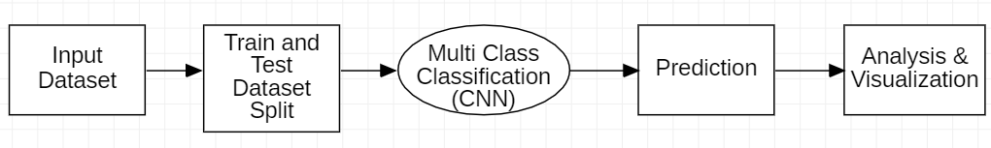

Figure 3.1: Project Architecture of Image based classification of malware using DL

### 

### 3.2 MODULES DESCRIPTION

A Convolutional Neural Network (ConvNet/CNN) is a Deep Learning algorithm which can take in an input image, assign importance (learnable weights and biases) to various aspects/objects in the image and be able to differentiate one from the other. The pre-processing required in a ConvNet is much lower as compared to other classification algorithms. While in primitive methods filters are hand-engineered, with enough training, ConvNets have the ability to learn these filters/characteristics.

The architecture of a ConvNet is analogous to that of the connectivity pattern of Neurons in the Human Brain and was inspired by the organization of the Visual Cortex. Individual neurons respond to stimuli only in a restricted region of the visual field known as the Receptive Field. A collection of such fields overlap to cover the entire visual area.

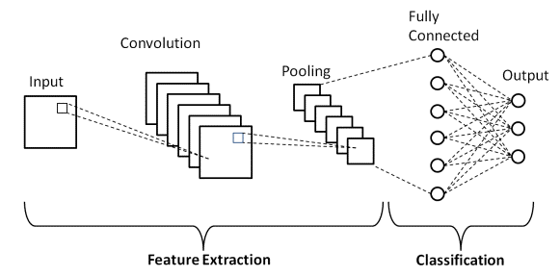

Figure 3.2: Convolutional Neural Network (CNN).

**Convolution layer:**

The convolution layer is the core building block of the CNN. It carries the main portion of the network’s computational load. This layer performs a dot product between two matrices, where one matrix is the set of learnable parameters otherwise known as a kernel, and the other matrix is the restricted portion of the receptive field. The kernel is spatially smaller than an image but is more in-depth. This means that, if the image is composed of three (RGB) channels, the kernel height and width will be spatially small, but the depth extends up to all three channels.

During the forward pass, the kernel slides across the height and width of the image-producing the image representation of that receptive region. This produces a two-dimensional representation of the image known as an activation map that gives the response of the kernel at each spatial position of the image. The sliding size of the kernel is called a stride.

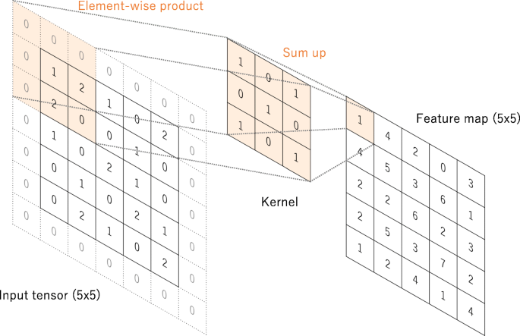

Figure 3.3: Convolutional Layer and Kernel.

**Pooling layer:**

Similar to the Convolutional Layer, the Pooling layer is responsible for reducing the spatial size of the Convolved Feature. This is to decrease the computational power required to process the data through dimensionality reduction. Furthermore, it is useful for extracting dominant features which are rotational and positional invariant, thus maintaining the process of effectively training of the model.

There are two types of Pooling: Max Pooling and Average Pooling. Max Pooling returns the maximum value from the portion of the image covered by the Kernel. On the other hand, Average Pooling returns the average of all the values from the portion of the image covered by the Kernel.

The Convolutional Layer and the Pooling Layer, together form the i-th layer of a Convolutional Neural Network. Depending on the complexities in the images, the number of such layers may be increased for capturing low-levels details even further, but at the cost of more computational power. After going through the above process, we have successfully enabled the model to understand the features.

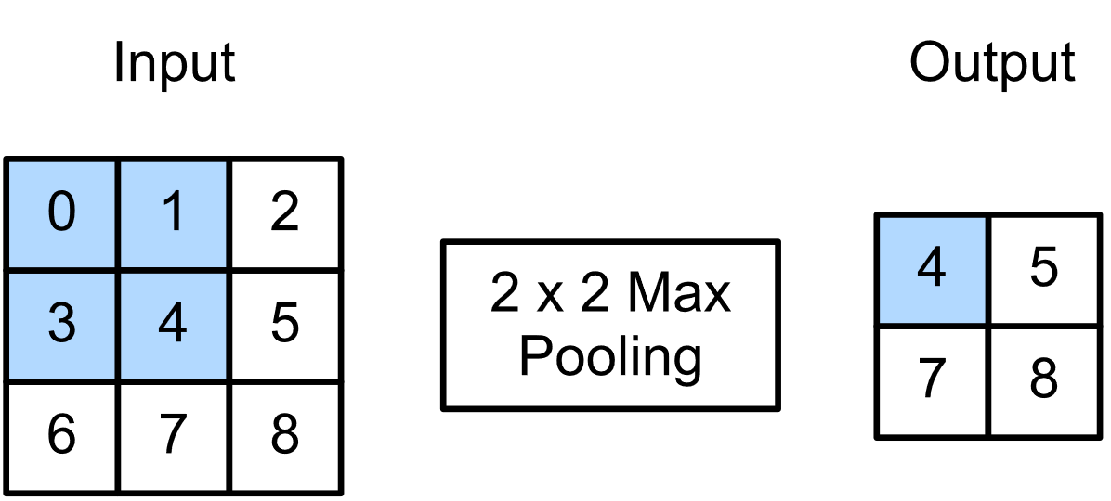

Figure 3.4: Pooling Layer (Max Pooling).

**Fully connected layer:**

Fully Connected Layer (also known as Hidden Layer) is simply, feed forward neural networks. Fully Connected Layers form the last few layers in the network. The input to the fully connected layer is the output from the final Pooling or Convolutional Layer, which is flattened and then fed into the fully connected layer.

We can add multiple such layers based on the depth to which we want to take our classification model. Note that this entirely depends on the training dataset. Output from the final hidden layer is sent to Softmax or Sigmoid function for probability distribution over final set of total number of classes.

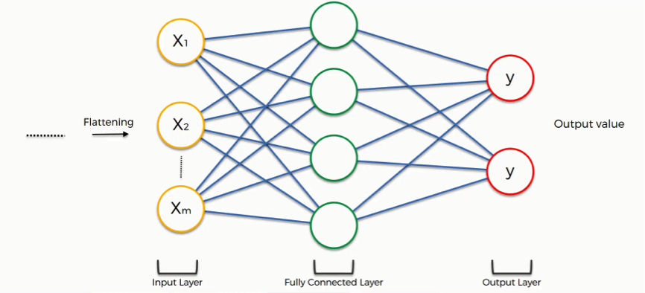

Figure 3.5: Fully Connected Layer.

**Softmax Layer:**

Softmax assigns decimal probabilities to each class in a multi-class problem. Those decimal probabilities must add up to 1.0. This additional constraint helps training converge more quickly than it otherwise would. Softmax is implemented through a neural network layer just before the output layer. The Softmax layer must have the same number of nodes as the output layer.

**Dropout Layer:**

The Dropout layer is a mask that nullifies the contribution of some neurons towards the next layer and leaves unmodified all others. We can apply a Dropout layer to the input vector, in which case it nullifies some of its features; but we can also apply it to a hidden layer, in which case it nullifies some hidden neurons.

Dropout layers are important in training CNNs because they prevent overfitting on the training data. If they aren’t present, the first batch of training samples influences the learning in a disproportionately high manner. This, in turn, would prevent the learning of features that appear only in later samples or batches.

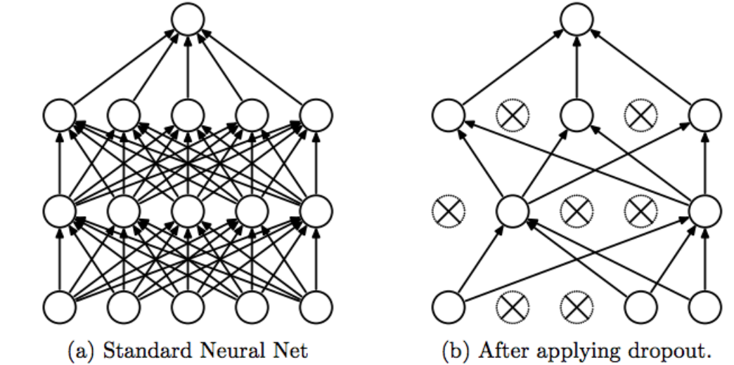

Figure 3.6: Dropout Layer.

**Confusion matrix:**

A confusion matrix is a summary of prediction results on a classification problem. The number of correct and incorrect predictions are summarized with count values and broken down by each class. This is the key to the confusion matrix. The confusion matrix shows the ways in which your classification model is confused when it makes predictions. It gives you insight not only into the errors being made by your classifier but more importantly the types of errors that are being made.

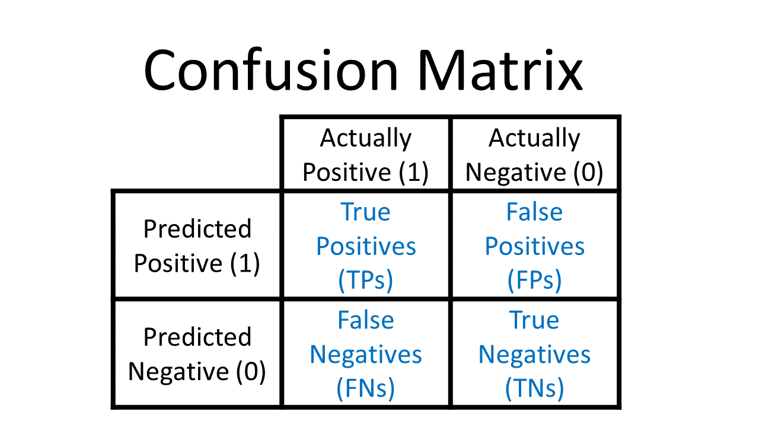

Figure 3.7: Confusion Matrix.

**How to Calculate a Confusion Matrix?**

1. You need a test dataset or a validation dataset with expected outcome values.
2. Make a prediction for each row in your test dataset.
3. From the expected outcomes and predictions count:

* The number of correct predictions for each class.
* The number of incorrect predictions for each class, organized by the class that was predicted.

These numbers are then organized into a table, or a matrix as follows:

* Expected down the side: Each row of the matrix corresponds to a predicted class.
* Predicted across the top: Each column of the matrix corresponds to an actual class.

The counts of correct and incorrect classification are then filled into the table. The total number of correct predictions for a class go into the expected row for that class value and the predicted column for that class value. In the same way, the total number of incorrect predictions for a class go into the expected row for that class value and the predicted column for that class value.

**MODULE 1: PRE-PROCESSING DATASET**

* Unzip the dataset: Unzipping is the act of extracting the files from a zipped single file or similar file archive. If the files in the package were also compressed (as they usually are), unzipping decompresses them.
* Data Augmentation: Data augmentation is the process of modifying, or “augmenting” a dataset with additional data. This additional data can be anything from images to text, and its use in machine learning algorithms helps improve their performance.

**MODULE 2: TRAIN THE MODEL**

* Train/Test split: The train-test split is used to estimate the performance of machine learning algorithms that are applicable for prediction-based Algorithms.
* Balance Class weight: Data are said to suffer the Class Imbalance Problem when the class distributions are highly imbalanced which leads to low predictive accuracy for the infrequent class.
* Compile and train model: Compile defines the loss function, the optimizer and the metrics. You need a compiled model to train (because training uses the loss function and the optimizer).

**MODULE 3: ANALYSIS**

* Finding Accuracy: It is the measurement used to determine which model is best at identifying relationships and patterns between variables in a dataset based on the input, or training, data.
* Plotting Confusion matrix: A Confusion matrix is an N x N matrix used for evaluating the performance of a classification model, where N is the number of target classes. The matrix compares the actual target values with those predicted by the machine learning model.

### 3.3 USE CASE DIAGRAM

In the use case diagram, we have one actor who is user/developer. The actor has right to compare the actual and predicted result of classification. These results can be clearly seen in confusion matrix.

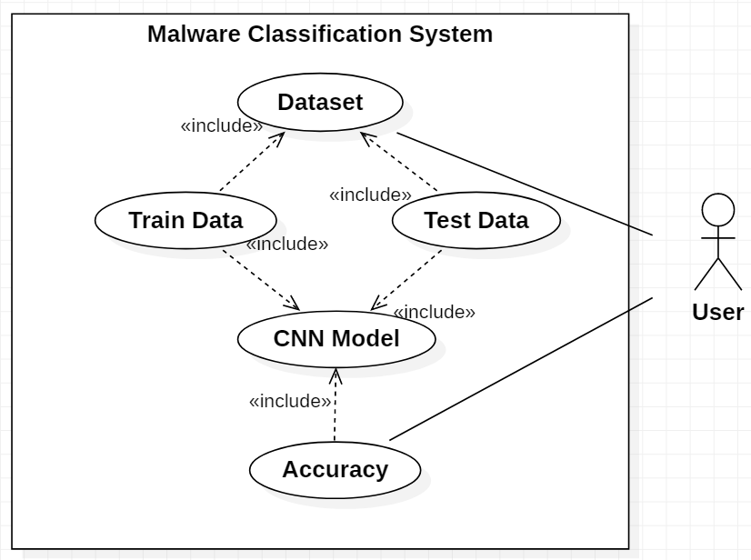

Figure 3.8: Use Case Diagram for Image based classification of malware using DL.

### 3.4 CLASS DIAGRAM

Class Diagram is a collection of classes and objects.

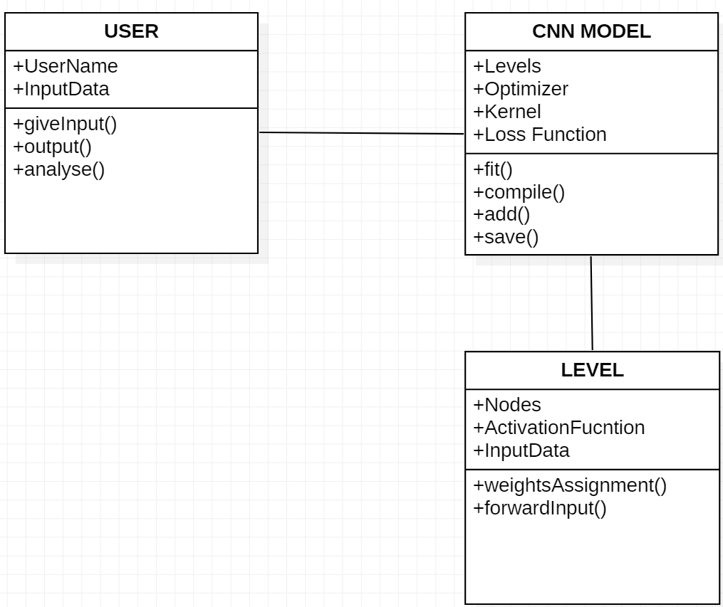

Figure 3.9: Class Diagram for Image based classification of malware using DL.

### 3.5 SEQUENCE DIAGRAM

Sequence diagram is a sequence of operations executed in our project.

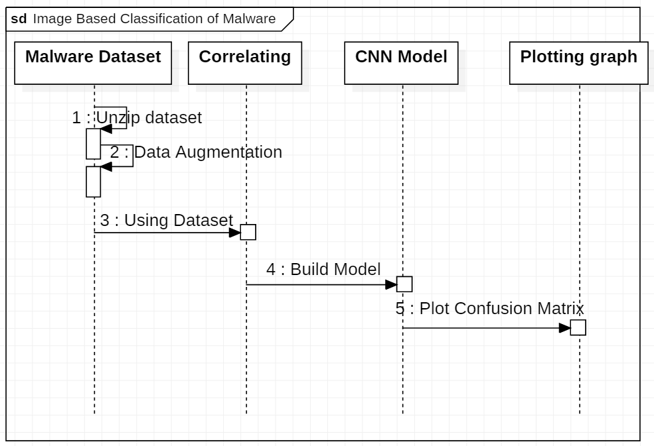

Figure 3.10: Sequence Diagram for Image based classification of malware using DL.

### 3.6 ACTIVITY DIAGRAM

It describes about flow of activity states.

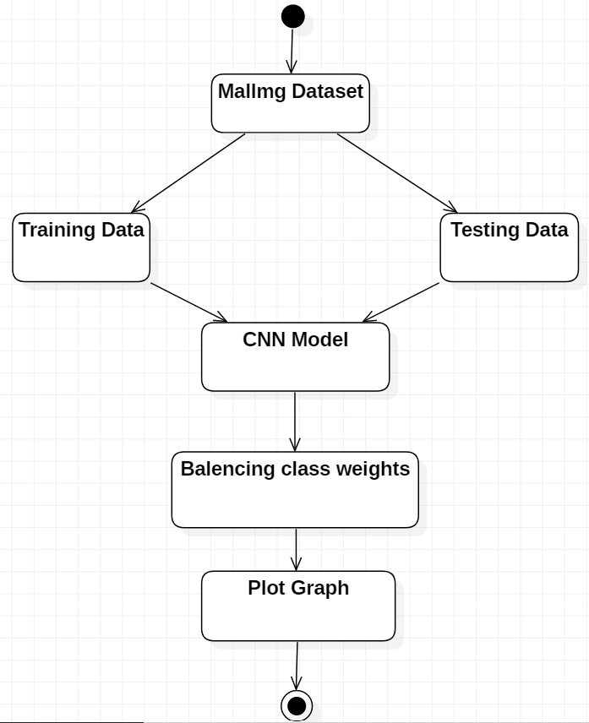

Figure 3.11: Activity Diagram for Image based classification of malware using DL.

# 4. IMPLEMENTATION

### 4. IMPLEMENTATION

### 4.1 SAMPLE CODE

MalwareClassification.ipnb:

!pip install -q kaggle

import sys

import os

from math import log

import numpy as np

import scipy as sp

from PIL import Image

import matplotlib.pyplot as plt

from google.colab import files

files.upload()

! mkdir ~/.kaggle

! cp kaggle.json ~/.kaggle/

! chmod 600 ~/.kaggle/kaggle.json

!kaggle datasets download -d keerthicheepurupalli/malimg-dataset9010

!unzip malimg-dataset9010.zip

from keras.preprocessing.image import ImageDataGenerator

from sklearn.model_selection import train_test_split

path_root = "/content/dataset_9010/dataset_9010/malimg_dataset/train"

batches = ImageDataGenerator().flow_from_directory(directory=path_root,

target_size=(64,64),

batch_size=10000)

batches.class_indices

imgs, labels = next(batches)

imgs.shape

labels.shape

def plots(ims, figsize=(20,30), rows=10, interp=False, titles=None):

if type(ims[0]) is np.ndarray:

ims = np.array(ims).astype(np.uint8)

if (ims.shape[-1] != 3):

ims = ims.transpose((0,2,3,1))

f = plt.figure(figsize=figsize)

cols = 10

19

for i in range(0,50):

sp = f.add_subplot(rows, cols, i+1)

sp.axis('Off')

if titles is not None:

sp.set_title(list(batches.class_indices.keys())[np.argmax(titles[i])], fontsize=16)

plt.imshow(ims[i], interpolation=None if interp else 'none')

plots(imgs, titles = labels)

classes = batches.class_indices.keys()

perc = (sum(labels)/labels.shape[0])*100

plt.xticks(rotation='vertical')

plt.bar(classes,perc)

from sklearn.model_selection import train_test_split

X_train, X_test, y_train, y_test = train_test_split(imgs/255.,labels, test_size=0.3)

X_train.shape

X_test.shape

y_train.shape

y_test.shape

import keras

from keras.models import Sequential, Input, Model

from keras.layers import Dense, Dropout, Flatten

from keras.layers import Conv2D, MaxPooling2D

from tensorflow.keras.layers import BatchNormalization

num_classes = 25

def malware_model():

Malware_model = Sequential()

Malware_model.add(Conv2D(30, kernel_size=(3, 3),

activation='relu',

input_shape=(64,64,3)))

Malware_model.add(MaxPooling2D(pool_size=(2, 2)))

Malware_model.add(Conv2D(15, (3, 3), activation='relu'))

Malware_model.add(MaxPooling2D(pool_size=(2, 2)))

Malware_model.add(Dropout(0.25))

Malware_model.add(Flatten())

Malware_model.add(Dense(128, activation='relu'))

Malware_model.add(Dropout(0.5))

Malware_model.add(Dense(50, activation='relu'))

Malware_model.add(Dense(num_classes, activation='softmax'))

Malware_model.compile(loss='categorical_crossentropy', optimizer = 'adam',

metrics=['accuracy'])

return Malware_model

Malware_model = malware_model()

Malware_model.summary()

y_train

y_train_new = np.argmax(y_train, axis=1)

y_train_new

from sklearn.utils import class_weight

class_weights = class_weight.compute_class_weight(class_weight='balanced',

classes = np.unique(y_train_new),

y = y_train_new)

class_weight_dict = dict(enumerate(class_weights))

class_weight_dict

Malware_model.fit(X_train, y_train, validation_data=(X_test, y_test), epochs=20,

class_weight=class_weight_dict)

scores = Malware_model.evaluate(X_test, y_test)

print('Final CNN accuracy: ', scores[1])

import numpy as np

import pandas as pd

y_pred = np.argmax(Malware_model.predict(X_test), axis=-1)

y_pred

y_test2 = np.argmax(y_test, axis=1)

y_test2

from sklearn import metrics

c_matrix = metrics.confusion_matrix(y_test2, y_pred)

import seaborn as sns

def confusion_matrix(confusion_matrix, class_names, figsize = (10,7), fontsize=14):

df_cm = pd.DataFrame(confusion_matrix, index=class_names, columns=class_names, )

fig = plt.figure(figsize=figsize)

try:

heatmap = sns.heatmap(df_cm, annot=True, fmt="d")

except ValueError:

raise ValueError("Confusion matrix values must be integers.")

heatmap.yaxis.set_ticklabels(heatmap.yaxis.get_ticklabels(), rotation=0,

ha='right',

fontsize=fontsize)

heatmap.xaxis.set_ticklabels(heatmap.xaxis.get_ticklabels(), rotation=45,

ha='right',

fontsize=fontsize)

plt.ylabel('True label')

plt.xlabel('Predicted label')

class_names= batches.class_indices.keys()

import pandas as pd

confusion_matrix(c_matrix, class_names, figsize = (20,7), fontsize=14)

…

21

# 5. SCREENSHOT

## 5. SCREENSHOT

### 5.1 SAMPLE DATASET

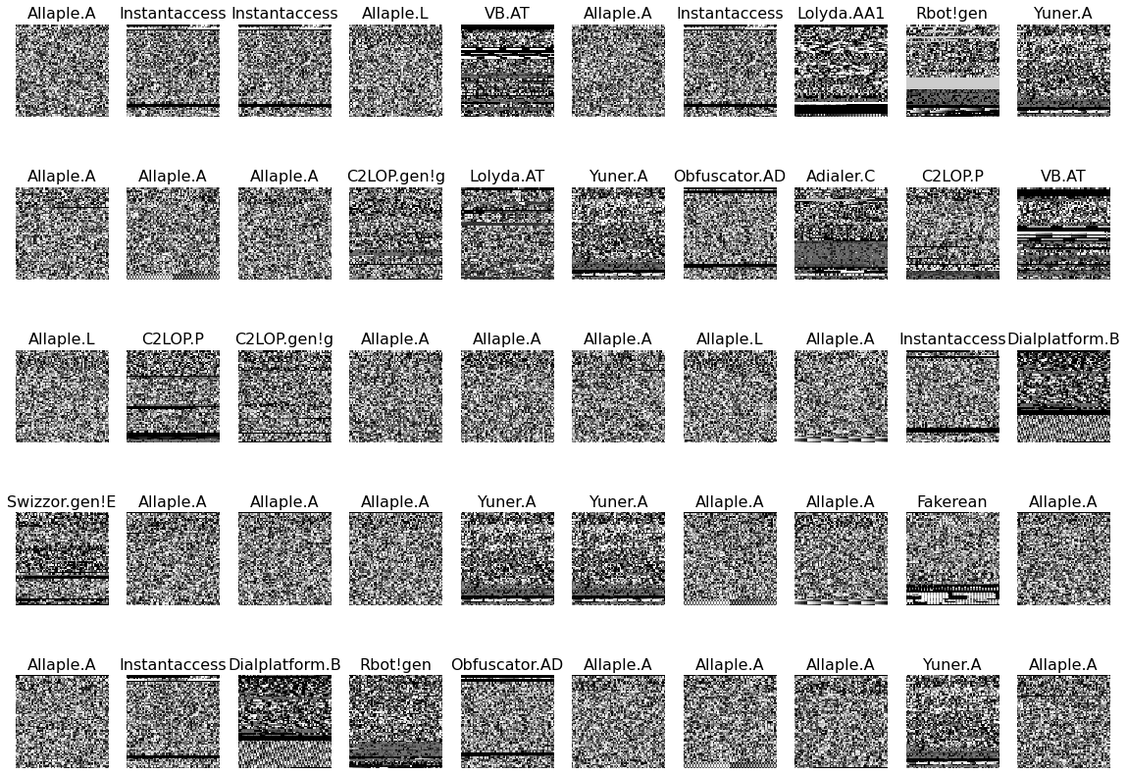

Screenshot 5.1: Sample Dataset of malimg-dataset9010.

### 5.2 DATASET OVERVIEW

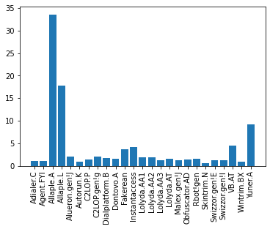

Screenshot 5.2: Dataset overview of malimg-dataset9010.

### 5.3 CONFUSION MATRIX

Confusion Matrix is used for result analysis, it plots a graph between actual and predicted output.

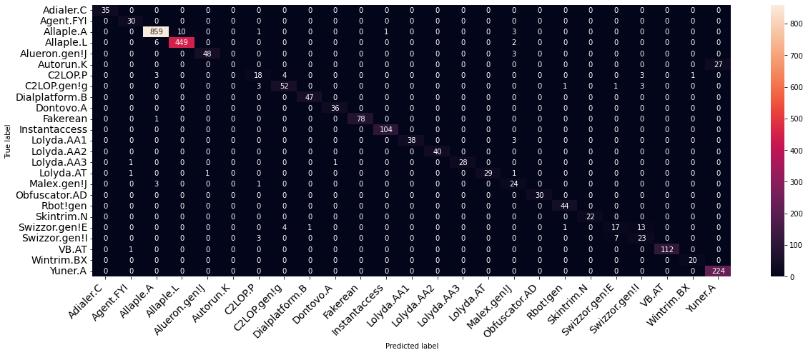

Screenshot 5.3: Confusion Matrix of malware model.

### 5.4 ACCURACY

The proposed model uses CNN multi-class classifier to achieves 89% accurate results with minimal rate of misclassification in less time and computational resources.

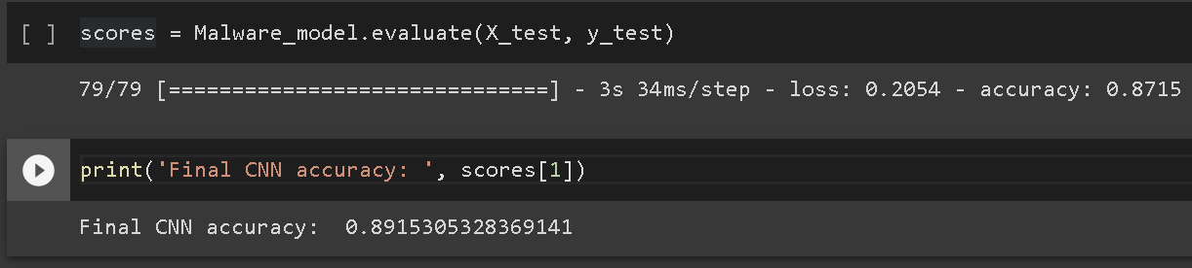

Screenshot 5.4: Recorded Accuracy of malware model.

# 6. TESTING

## 6. TESTING

### 6.1 INTRODUCTION TO TESTING

The purpose of testing is to discover errors. Testing is the process of trying to discover every conceivable fault or weakness in a work product. It provides a way to check the functionality of components, subassemblies, assemblies and/or a finished product. It is the process of exercising software with the intent of ensuring that the Software system meets its requirements and user expectations and does not fail in an unacceptable manner. There are various types of test. Each test type addresses a specific testing requirement.

### 6.2 TYPES OF TESTING

### 6.2.1 UNIT TESTING

Unit tests having several test cases that ensure that your internal program logic works correctly and that your program inputs produce valid output. All decision branches and internal code flows need to be validated. This is a test of the individual software units of your application. This is done after the completion of a single unit before integration. This is knowledge about its design and is an invasive structural test. Unit tests run basic tests at the component level to test specific business processes, applications, and system configurations. Unit tests ensure that every path in a business process corresponds exactly to the documented specification and contains well-defined inputs and expected results.

### 6.2.2 INTEGRATION TESTING

Integration tests are designed to test integrated software components to determine if they actually run as one program. The tests are event driven and are interested in the basic results of the screen or panel. Integration testing shows that the combination of components is correct and consistent, as indicated by the success of unit testing, even though the components are individually filled. Mixing tests are specially designed to identify problems that arise from composite parts.

### 6.2.3 FUNCTIONAL TESTING

Functional tests provide systematic demonstrations that functions tested are available as specified by the business and technical requirements, system documentation, and user manuals.

Functional testing is centered on the following:

Valid Input : identified classes of valid input must be accepted. Invalid Input : identified classes of invalid input must be rejected. Functions : identified functions must be exercised.

Output : identified classes of application outputs must be exercised.

Systems : interfacing systems or procedures must be invoked.

The design and adjustment of performance appraisals focuses on special requirements, tasks, or special test cases. In addition, systematic coverage pertaining to identify Business process flows; data fields, predefined processes.

### 6.3 TEST CASES

### 6.3.1 CLASSIFICATION

|  |  |  |  |  |
| --- | --- | --- | --- | --- |
| Test case ID | Test case name | Purpose | Input | Output |
| 1 | Classification Test 1 | To test classifier model | An Adialer.C image | Classified as Adialer.C |
| 2 | Classification Test 2 | To test classifier model | An Agent.FYI image | Classified as Agent.FYI |
| 3 | Classification Test 3 | To test classifier model | An Allaple.A image | Classified as Allaple.A |
| 4 | Classification Test 4 | To test classifier model | An Allaple.L image | Classified as Allaple.L |
| 5 | Classification Test 5 | To test classifier model | An Alueron.gen!J image | Classified as Alueron.gen!J |
| 6 | Classification Test 6 | To test classifier model | An Autorun.K image | Wrong Classified as Allaple.A |
| 7 | Classification Test 7 | To test classifier model | A C2LOP.P image | Wrong Classified as C2LOP.gen!g |
| 8 | Classification Test 8 | To test classifier model | A C2LOP.gen!g image | Classified as  C2LOP.gen!g |
| 9 | Classification Test 9 | To test classifier model | A Dialplatform.B image | Classified as Dialplatform.B |
| 10 | Classification Test 10 | To test classifier model | A Dontovo.A image | Classified as Dontovo.A |

|  |  |  |  |  |
| --- | --- | --- | --- | --- |
| Test case ID | Test case name | Purpose | Input | Output |
| 11 | Classification Test 11 | To test classifier model | A Fakerean image | Classified as Fakerean |
| 12 | Classification Test 12 | To test classifier model | An Instantaccess image | Classified as Instantaccess |
| 13 | Classification Test 13 | To test classifier model | A Lolyda.AA1 image | Classified as Lolyda.AA1 |
| 14 | Classification Test 14 | To test classifier model | A Lolyda.AA2 image | Classified as Lolyda.AA2 |
| 15 | Classification Test 15 | To test classifier model | A Lolyda.AA3 image | Classified as Lolyda.AA3 |
| 16 | Classification Test 16 | To test classifier model | A Lolyda.AT image | Classified as Lolyda.AT |
| 17 | Classification Test 17 | To test classifier model | A Malex.gen!J image | Worng Classified as Lolyda.AA1 |
| 18 | Classification Test 18 | To test classifier model | An Obfuscator.AD image | Classified as Obfuscator.AD |
| 19 | Classification Test 19 | To test classifier model | A Rbot!gen image | Classified as Rbot!gen |
| 20 | Classification Test 20 | To test classifier model | A Skintrim.N image | Classified as Skintrim.N |
| 21 | Classification Test 21 | To test classifier model | A Swizzor.gen!E image | Wrong Classified as Swizzor.gen!I |
| 22 | Classification Test 22 | To test classifier model | A Swizzor.gen!I image | Wrong Classified as Swizzor.gen!E |
| 23 | Classification Test 23 | To test classifier model | A VB.AT image | Classified as VB.AT |
| 24 | Classification Test 24 | To test classifier model | A Wintrim.BX image | Classified as Wintrim.BX |
| 25 | Classification Test 25 | To test classifier model | A Yuner.A image | Classified as Yuner.A |

**7. CONCLUSION**

**7. CONCLUSION & FUTURE SCOPE**

### 7.1 PROJECT CONCLUSION

Malware is most commonly used for performing attacks by cyber attackers. To control the attackers from performing attacks, stealing the information, and harming computer systems, security specialists and antimalware software companies are constantly working on identifying new methods. The proposed model uses CNN multi-class classifier to achieves 89% accurate results with minimal rate of misclassification in less time and computational resources.

### 7.2 PROJECT FUTURE SCOPE

In future we can use other type of convolutional neural networks by downloading the modules directly into the project files. The proposed system is much faster and efficient to identify the malware. Hence it can be used in antivirus software to determine malicious files. This model can combinedly used with other models to detect malware. This model can grow if we can combine other datasets.

# 8. BIBLIOGRAPHY

## 8. BIBLIOGRAPHY

### 8.1 REFERENCES

[1] Gibert, D., Mateu, C., & Planes, J. (2020). HYDRA: A Multimodal Deep

Learning Framework for Malware Classification. Computers & Security, 101873. doi:10.1016/j.cose.2020.101873

[2] Alsulami, B., & Mancoridis, S. (2018). Behavioral Malware Classification

using Convolutional Recurrent Neural Networks. 2018 13th International Conference on Malicious and Unwanted Software (MALWARE). doi:10.1109/malware.2018.8659358

[3] Zhao, Jing & Basole, Samanvitha & Stamp, Mark. (2021). Malware

Classification with GMM-HMM Models.

[4] Kalash, M., Rochan, M., Mohammed, N., Bruce, N. D. B., Wang, Y., & Iqbal,

F. (2018). Malware Classification with Deep Convolutional Neural Networks. 2018 9th IFIP International Conference on New Technologies, Mobility and Security (NTMS). doi:10.1109/ntms.2018.8328749

[5] Dang, Dennis & Di Troia, Fabio & Stamp, Mark. (2021).

Malware Classification Using Long Short-Term Memory Models

### 8.2 WEBSITES

[1] [https://](https://www.wikipedia.org)resources.malwarebytes.com/files/2020/02/2020_State-of-Malware-Report.pdf

[2] [https://](https://opencv.org)docs.broadcom.com/docs/istr-24-2019-en